Food production shocks across land and sea
Supplementary information
Richard S. Cottrell, Kirsty Nash, Benjamin S. Halpern, Stuart P. Corney, Aysha Fleming, Elizabeth A. Fulton, Sara Hornborg, Alexandra Johne, Tomas A. Remenyi, Reg A. Watson, Julia L. Blanchard

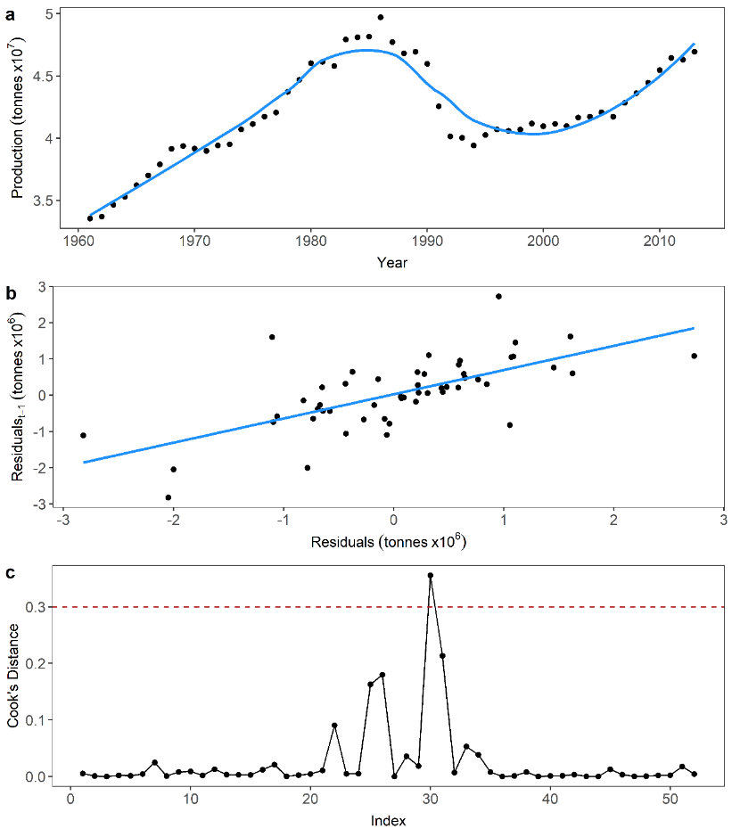
Figure S1 - Statistical shock detection method. a. Local polynomial regression (LOESS) model fitted to food production time-series b. Regression of model residuals against lag-1 residuals c. Production shock in 1991 identified as outlier from regression in b using Cook’s Distance measures
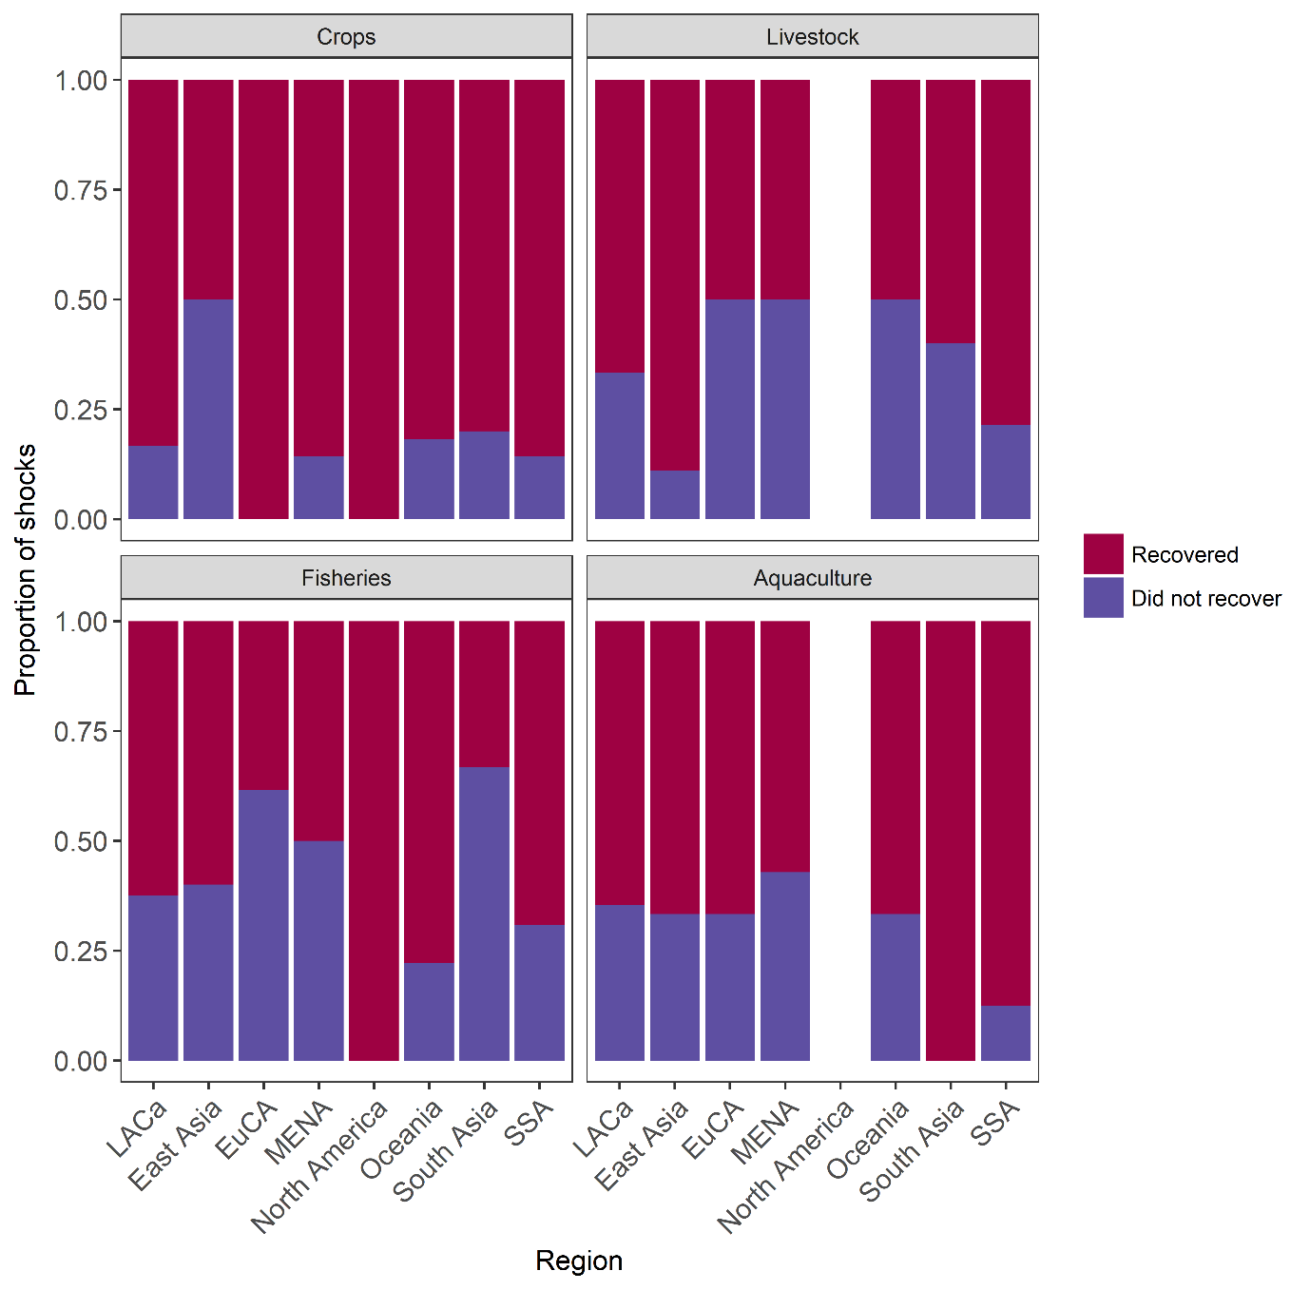
Figure S2 – Proportion of shocks recovered or not during study period in crops, livestock, fisheries and aquaculture sectors across geographic region.

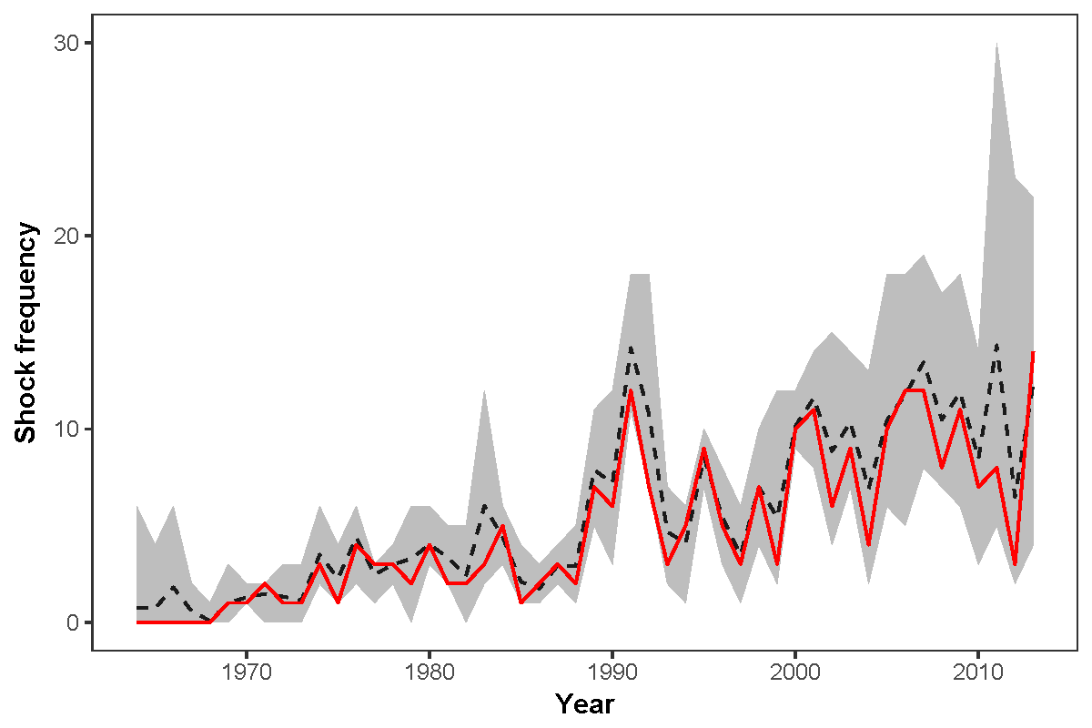
Figure S3 – Shock frequency through time summed across all sectors for a range of parameter combinations. Light grey confidence interval represents range of plausible shock frequencies dependent on span, baseline and average type used in shock detection. Dashed black line is mean of the confidence interval frequencies. Solid red line represents parameter combination that minimizes the sum of squared residuals with the confidence interval mean (parameters selected for this analysis).
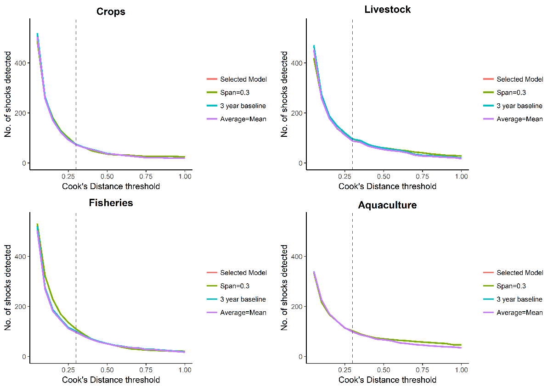
Figure S4– Comparisons of number of shocks detected in crop, livestock, fisheries and aquaculture time series with incremental changes to Cook’s distance values. Lines represent either the combination of model parameters used in this study (‘Selected Model’, LOESS span = 0.6, production baseline = 7 years and average type used = median), or repeated with changes to model span, production baseline or average type. Vertical dashed line represents the Cook’s distance value of 0.3 used in this study

Table S1 – Proportion of imposed shocks detected in simulated time series for different time series standard deviations and shock size combinations.
 |  | Standard deviation
 |  | 0.1 | 0.2 | 0.3 | 0.4 | 0.5 | 0.6 | 0.7 | 0.8 | 0.9 | 1
Magnitude | 0 | 0.003 | 0.001 | 0.001 | 0.001 | 0.003 | 0.001 | 0.002 | 0.001 | 0.001 | 0.003
Magnitude | 0.5 | 0.82 | 0.159 | 0.043 | 0.023 | 0.018 | 0.012 | 0.006 | 0.006 | 0.006 | 0.006
Magnitude | 1 | 1 | 0.805 | 0.345 | 0.161 | 0.061 | 0.036 | 0.018 | 0.017 | 0.008 | 0.01
Magnitude | 1.5 | 1 | 0.995 | 0.786 | 0.459 | 0.246 | 0.122 | 0.089 | 0.052 | 0.035 | 0.026
Magnitude | 2 | 1 | 1 | 0.982 | 0.81 | 0.526 | 0.352 | 0.22 | 0.133 | 0.082 | 0.065
Magnitude | 2.5 | 1 | 1 | 0.997 | 0.97 | 0.781 | 0.603 | 0.408 | 0.273 | 0.177 | 0.131
Magnitude | 3 | 1 | 1 | 1 | 0.994 | 0.954 | 0.813 | 0.651 | 0.469 | 0.301 | 0.22
Magnitude | 3.5 | 1 | 1 | 1 | 1 | 0.99 | 0.934 | 0.813 | 0.666 | 0.506 | 0.41
Magnitude | 4 | 1 | 1 | 1 | 1 | 1 | 0.973 | 0.911 | 0.802 | 0.652 | 0.565
Magnitude | 4.5 | 1 | 1 | 1 | 1 | 1 | 0.995 | 0.974 | 0.906 | 0.824 | 0.668
Magnitude | 5 | 1 | 1 | 1 | 1 | 1 | 1 | 0.99 | 0.957 | 0.902 | 0.821
Magnitude | 5.5 | 1 | 1 | 1 | 1 | 1 | 1 | 0.997 | 0.984 | 0.952 | 0.878
Magnitude | 6 | 1 | 1 | 1 | 1 | 1 | 1 | 0.999 | 0.995 | 0.976 | 0.942

Drivers of shocks
Table S2 – Identified causes for production shocks across all sectors. Asterisks indicate possible drivers for shocks of an unknown cause based on events occurring in country at the shock point. We highlight shocks that did not recover by the end of the time series (2013) by ^{NR} adjacent to the number of years between the shock point and 2013.
Sector | Country | Year | Shock size  (tonnes) | Recovery time (years) | Driver | Reference | Category
Crops | Afghanistan | 2001 | 1146371 | 1 | Severe droughts from 1999-2001 | ¹ | Climate/weather events
Crops | Albania | 1992 | 700580 | 16 | Transition to market-based economy in early 1990s | ² | Geopolitical/ economic events
Crops | Antigua and Barbuda | 1995 | 471 | 1 | Reduction in crop output associated with damage from Hurricane Luis | ³ | Climate/ weather events
Crops | Australia | 2007 | 12018352 | 1 | Annual rainfall in 2006 40-60% below normal over most of the country, in part caused by the 2006/07 El Niño event | ^{4,5} | Climate/weather events
Crops | Bahrain | 1981 | 30551 | 32^{NR} | Urban expansion and salinization of ground water led to significant losses in agricultural areas | ⁶ | Mismanagement
Crops | Bermuda | 1971 | 1017 | 14 | Oil price fluctuations in the US economy from 1969- 1972* | ⁷ | Unknown
Crops | Bhutan | 2000 | 135694 | 4 | Heavy seasonal monsoon rainfall and flash floods across the country | ^{8,9} | Climate/weather events
Crops | Burundi | 2012 | 87394 | 1 | Dramatic decrease in banana production between 2007 and 2012 due to the effects of Xanthomonas wilt | ¹⁰ | Other
Crops | Cameroon | 1987 | 367152 | 1 | Severe economic crisis due to decline in world prices of oil, coffee and cocoa resulted in shrinking agricultural investment | ^{11,12} | Geopolitical/economic events
Crops | Cayman Islands | 2004 | 240 | 9^{NR} | Hurricane Ivan caused damage across agricultural sector of over US $5.6 millions | ¹³ | Climate/weather events
Crops | Chile | 2007 | 986109 | 1 | Rising world food prices combined with severe winter frosts in Chile reduced yields for vegetables, pulses and some fruits | ¹⁴ | Climate/weather & geopolitical/economic events
Crops | Comoros | 1985 | 8250 | 1 | Effects of Cyclone Kamisy on Cassava and Yams* |  | Unknown
Crops | Cuba | 2006 | 1469850 | 7 ^{NR} | Restructuring in sugar industry led to systemic declines in agricultural productivity | ¹⁵ | Geopolitical/economic events
Crops | DPRK | 1995 | 6800710 | 18 ^{NR} | Torrential rainfall causing severe flooding and mudslides affecting up to 16% of agricultural areas | ¹⁶ | Climate/weather events & Mismanagement
Crops | DPRK | 1996 | 8298824 | 17 ^{NR} | As above with recurrent flooding into 1996. | ¹⁶ | Mismanagement
Crops | Democratic Republic of the Congo | 1995 | 3396734 | 18 ^{NR} | Civil unrest during the 1990s preventing agricultural investment and displacing the rural work force. | ^{17,18} | Geopolitical/ economic events
Crops | Dominica | 1979 | 11248 | 2 | Hurricane David effects on banana crop | ¹⁹ | Climate/weather events
Crops | Dominican Republic | 2008 | 129906 | 1 | Destruction of plantain crop by Tropical Storm Noel late 2007 | ²⁰ | Climate/weather events
Crops | Ecuador | 1998 | 412931 | 1 | Heavy rains causing widespread flooding and crop failures | ²¹ | Climate/weather events
Crops | French Polynesia | 2006 | 204 | 1 | Unknown |  | Unknown
Crops | Gambia | 2011 | 94155 | 1 | Severe drought reducing crop production by over 50% in some crops e.g. Millet | ²² | Climate/weather events
Crops | Guadeloupe | 1980 | 96781 | 2 | Hurricane David in 1979 followed by Hurricane Allen in 1980 destroying the banana crop | ²³ | Climate/weather events
Crops | Guam | 2002 | 1102 | 2 | Super-typhoon Pongsona causing widespread devastation in Guam accounting for $130 million damage* | ²⁴ | Unknown
Crops | India | 2002 | 14092939 | 1 | Severe drought across major growing regions affecting major kharif crops | ²⁵ | Climate/weather events
Crops | Iran (Islamic Republic of) | 2008 | 6510785 | 1 | Drought reducing wheat production by 34% | ²⁶ | Climate/weather events
Crops | Iraq | 2009 | 2134230 | 1 | Drought 2009 -10 in major wheat growing areas | ²⁷ | Climate/weather events
Crops | Kiribati | 1989 | 2800 | 1 | Drought and effect largely on coconut plantations | ²⁸ | Climate/weather events
Crops | Liberia | 1995 | 136526 | 1 | Liberian Civil War | ²⁹ | Geopolitical/economic events
Crops | Libya | 1971 | 10307 | 1 | Dip in productivity after 1969 coup d'etat* |  | Unknown
Crops | Libya | 1977 | 60112 | 1 | Libya-Egypt War* |  | Unknown
Crops | Madagascar | 2013 | 484817 | 2 | Drought causes large crop and depletion of seed stores | ³⁰ | Climate/weather events
Crops | Malawi | 2005 | 1600136 | 1 | Drought reduced staple harvest to only 37% of requirements | ³¹ | Climate/weather events
Crops | Maldives | 1990 | 16743 | 23 ^{NR} | Unknown |  | Unknown
Crops | Mali | 2013 | 484899 | 2 | Northern Mali Conflict displacing over 300 000 people and disrupting crop production | ³² | Geopolitical/economic events
Crops | Namibia | 1998 | 16707 | 1 | Severe drought affecting 25000 people and abandonment of farms | ^{24,33} | Climate/weather events
Crops | Nauru | 2007 | 272 | 6 ^{NR} | Significant decline in coconut crop due to hispid beetles infestations | ³⁴ | Other
Crops | Nauru | 2008 | 234 | 5 ^{NR} | Significant decline of coconuts due to hispid beetles infestations | ³⁴ | Other
Crops | Nigeria | 2009 | 21555081 | 1 | Initernal conflict throughout Nigeria reducing agricultural output | ³² | Geopolitical/economic events
Crops | Niue | 1990 | 1217 | 6 | Banana, breadfruit, papaya and taro crops devastated by Cyclone Ofa | ³⁵ | Climate/weather events
Crops | Norway | 1976 | 288148 | 1 | Precipitation deficit evident in late winter of 1975 and drought into 1976 | ³⁶ | Climate/weather events
Crops | Pakistan | 2002 | 199835 | 1 | Drought from 1999 through 2002 caused 70% reduction in wheat among other crops | ³⁷ | Climate/weather events
Crops | Paraguay | 2009 | 485042 | 1 | Severe drought required immediate relief for agricultural livelihoods | ³⁸ | Climate/weather events
Crops | Peru | 1990 | 846197 | 1 | Lack of investment and structural changes in agriculture in the early 1990s through recession | ³⁹ | Geopolitical/economic events
Crops | Republic of Korea | 1980 | 2202191 | 1 | Unknown |  | Unknown
Crops | Saint Kitts and Nevis | 1990 | 598 | 1 | Hurrican Hugo caused major damage to crops, particularly sugar towards end of 1989 | ⁴⁰ | Climate/weather events
Crops | Saudi Arabia | 1995 | 371562 | 9 | Economic pressure forced a reduction in subsidies for wheat and barley growing | ⁴¹ | Policy change
Crops | Somalia | 1991 | 673387 | 22 ^{NR} | Civil war displaced over a million people and decimated agricultural production (the main livelihood for rural Somalians) | ⁴² | Geopolitical/economic events
Crops | Syrian Arab Republic | 1989 | 2443833 | 1 | Drought affecting wheat crop | ⁴³ | Climate/weather events
Crops | Timor-Leste | 2011 | 96394 | 2 | Disrupted planting for 2011 due to severe La Nina flooding in 2010 | ⁴⁴ | Climate/weather events
Crops | Togo | 2013 | 117639 | 2 | Drought reducing harvest and planting of soy and rice | ⁴⁵ | Climate/weather events
Crops | Tokelau | 1994 | 101 | 10 | Unknown |  | Unknown
Crops | Tokelau | 2006 | 8 | 2 | Unknown |  | Unknown
Crops | United Kingdom | 1976 | 7054926 | 1 | Major drought - lowest rainfall in the UK in over 200 years resulting 20-30% drops in potato, oilseed and wheat | ⁴⁶ | Climate/weather events
Crops | United Republic of Tanzania | 2003 | 624231 | 1 | Drought in northern and central Tanzania affecting 2 million people. 85% of sorghum, maize and groundnuts affected | ⁴⁷ | Climate/weather events
Crops | Vanuatu | 1995 | 3273 | 1 | Unknown |  | Unknown
Crops | Venezuela (Bolivarian Republic of) | 2009 | 306179 | 2 | Drought in 2009 due to El Nino event, 70-80% of Venzeuelan rice and maize affected | ^{48,49} | Climate/weather events
Crops | Wallis and Futuna Islands | 2006 | 2009 | 7 | Unknown |  | Unknown
Livestock | Argentina | 2003 | 1576886 | 1 | Foot and Mouth Disease outbreak in 2000 leading to further declines until 2003 | ⁵⁰ | Other
Livestock | Bahamas | 2000 | 3997 | 13 | Hurricane Floyd with huge impact on agriculture* | ⁵¹ | Climate/weather events
Livestock | Bangladesh | 1980 | 191496 | 4 | Drought over 7 major growing regions in 1980 | ⁵² | Climate/weather events
Livestock | Barbados | 1992 | 3175 | 3 | Downturn in productivity following economic recession. Agricultural output declined between 1991 and 1994 due to poorly performing export sectors - largely due to the 1990 oil price shock | ⁵³ | Geopolitical/economic events
Livestock | Belize | 1989 | 6115 | 1 | Unknown |  | Unknown
Livestock | Bhutan | 2009 | 4471 | 4 ^{NR} | Agricultural damage from flash floods from cyclone Aila influenced 12 of 20 districts in Bhutan | ^{54,55} | Climate/weather events
Livestock | Bulgaria | 1991 | 742790 | 22 ^{NR} | Dissolution of Council for Mutual Economic Assistance (COMECON) resulted in trade disruption for Bulgarian livestock. Production output dropped nearly 15% from 1988 to 1991. By 1993 cattle inventories were down 40% and poultry 53% from 1988 levels | ⁵⁶ | Geopolitical/economic events
Livestock | Burkina Faso | 2013 | 73220 | 1 ^{NR} | Floods displaced 6712 people in Burkino Faso and inundated agricultural lands | ⁴⁵ | Climate/weather events
Livestock | Cabo Verde | 2011 | 17237 | 2 ^{NR} | Unknown |  | Unknown
Livestock | Chad | 1984 | 50096 | 2 | Severe drought aggravated by civil war in Chad. Huge livestock losses throughout Sahelian Africa | ⁵⁷ | Climate/weather events
Livestock | China, Macao SAR | 2008 | 3239 | 5 ^{NR} | H5N1 avian influenza outbreak across the region; poultry production decimated | ^{58,59} | Other
Livestock | Côte d'Ivoire | 1998 | 53540 | 6 | Unknown |  | Unknown
Livestock | Cuba | 1991 | 385299 | 22 ^{NR} | Loss of subsidized petroleum, fertilizer subsides and export markets from USSR dissolution Gross agrcultural output declined by 40% | ⁶⁰ | Geopolitical/economic events
Livestock | DPRK | 1992 | 107760 | 9 | Cessation of subsidised coal and oil from USSR following demise and subsequent withdrawal of aid from China. Further declines in 1994 after China withdrew. | ¹⁶ | Geopolitical/economic events
Livestock | DPRK | 1997 | 164730 | 2 | Food production continued to dip until 1997 following floods 1995-96. | ^{16,61} | Climate/weather & geopolitical/economic events
Livestock | Dominica | 2005 | 1251 | 2 | Productivity decline during 2000s across the agriculture sector due to rural-urban migration in younger demographic | ⁶² | Geopolitical/economic events
Livestock | Falkland Islands (Malvinas) | 1996 | 808 | 17 ^{NR} | Ovine hytadosis prevalence from early 1990s, high slaughter in 1994-95 revealed slump in 1996 | ⁶³ | Other
Livestock | Former Czechoslovakia | 1991 | 1197866 | 22 ^{NR} | Velvet Revolution and transition to market-based economy | ⁶⁴ | Geopolitical/economic events
Livestock | Germany | 1991 | 5150508 | 19 | Decentralisation of agricultural production following the demise of COMECON and reunification with West Germany | ⁶⁵ | Geopolitical/economic events
Livestock | Greenland | 1972 | 332 | 7 | Collapse of reindeers herds either a result of mass starvation over winter or possibly issues with data reporting/ management between years | ⁶⁶ | Mismanagement & policy change
Livestock | Guam | 1989 | 774 | 24 ^{NR} | Abandonment of agricultural livelihoods in the late 1980s - number of farmers across Guam crashed in 1987 after Cyclone Lynn | ⁶⁷ | Climate/weather & geopolitical/economic events
Livestock | Hungary | 1991 | 719965 | 22 ^{NR} | Dissolution of COMECON reduced inputs and markets for export and competition from western European countries led to a massive decline in agricultural productivity | ⁶⁸ | Geopolitical/economic events
Livestock | Indonesia | 1998 | 395732 | 3 | Drought driven by El Nino combined with Asian economic crisis | ⁶⁹ | Climate/weather events
Livestock | Iraq | 1991 | 549893 | 22 ^{NR} | Sanctions on Iraq during first Gulf War led to complete cut-off of imported feed grains. Domestic feed grain supply also decreased as it was redirected to human food. | ⁷⁰ | Geopolitical/economic events
Livestock | Iraq | 2003 | 300858 | 10 ^{NR} | Invasion of Iraq during second gulf war | ⁷⁰ | Geopolitical/economic events
Livestock | Kuwait | 1991 | 125192 | 5 | First Gulf War and Invasion of Kuwait by Iraq | ⁷¹ | Geopolitical/economic events
Livestock | Lebanon | 2011 | 8703 | 1 | Severe drought from 2007 through 2010 across fertile crescent | ⁷² | Climate/weather events
Livestock | Malawi | 2002 | 18307 | 2 | Malawi food crisis induced by floods in 2001 and complacency of projected food production. IMF encouraged sale (and so depletion of grain stores). Rush to sell livestock for staples leading to flooded market and a crash in livestock prices. Collapse of many rural livelihoods even migration to neighbouring Zambia. | ⁷³ | Climate/weather & geopolitical/economic events
Livestock | Malaysia | 1999 | 231740 | 3 | Nipah Virus in Swine Industry | ⁷⁴ | Other
Livestock | Maldives | 2005 | 400 | 8 ^{NR} | 2004 Tsunami | ⁷⁵ | Other
Livestock | Mali | 2013 | 46482 | 2 | Northern Mali Conflict displacing over 300 000 people and disrupting agriculture | ³² | Geopolitical/economic events
Livestock | Mauritania | 1974 | 82840 | 4 | Drought from 1968 -1972 causes large losses to pastoralists as herd numbers dwindle to 1.5 million head | ⁷⁶ | Climate/weather events
Livestock | Mauritius | 1978 | 4688 | 8 | Severe economic crisis hindering agriculture and trade of agricultural goods | ⁷⁷ | Geopolitical/economic events
Livestock | Mexico | 1989 | 1887191 | 2 | Successive droughts and economic crises from 1986-1989 | ⁷⁸ | Climate/weather & geopolitical/economic events
Livestock | Mongolia | 2001 | 81647 | 7 | 20 Million head of livestock perished in two mass mortality events (dzuds) in between 2000-2002 and 2009-2010. Dzuds driven by a combination of summer droughts, heavy snowfall, high winds, and extremely low winter temperatures | ⁷⁹ | Climate/weather events
Livestock | Mongolia | 2010 | 74802 | 1 | 20 Million head of livestock perished in two mass mortality events (dzuds) in between 2000-2002 and 2009-2010. Dzuds driven by a combination of summer droughts, heavy snowfall, high winds, and extremely low winter temperatures | ⁷⁹ | Climate/weather events
Livestock | Montserrat | 2006 | 659 | 7 ^{NR} | Economic downturn induced by infrastructure damage from the eruption of Soufriere volcano in 2005 | ^{80,81} | Other
Livestock | Nauru | 1976 | 4 | 2 | Unknown |  | Unknown
Livestock | Nicaragua | 1980 | 322697 | 19 | Nicaraguan civil war causing loss of production facilities or dangerous conditions inhibiting producers livelihoods. Large production losses across the country totalling USD $ 4.3 million in 1981 | ⁸² | Geopolitical/economic events
Livestock | Niger | 1984 | 65563 | 6 | Drought reduced feed crops and fodder yielding insufficient grazing or feed for cattle in the second half of 1984 | ⁸³ | Climate/weather events
Livestock | Nigeria | 2011 | 89523 | 1 | Significant floods in southern Nigeria causing livestock losses | ⁸⁴ | Climate/weather events
Livestock | Norway | 2000 | 145906 | 13 | Subsidy system reform incentivising fewer small farms and more large scale farms causing a restructure within Norwegian agriculture | ⁸⁵ | Policy change
Livestock | Republic of Korea | 2005 | 41664 | 1 | Outbreak of food and mouth disease | ⁸⁶ | Other
Livestock | Saint Kitts and Nevis | 2006 | 449 | 7 ^{NR} | Combination of agricultural theft, insufficient grazing lands left many livestock rearers unwilling to sell livestock in 2005 onwards | ⁸⁷ | Geopolitical/economic events
Livestock | Sao Tome | 1974 | 295 | 2 | Widespread disruption with a shift in political regime during Carnation Revolution* | ⁸⁸ | Unknown
Livestock | Seychelles | 2002 | 1583 | 11 ^{NR} | Unknown |  | Unknown
Livestock | Sierra Leone | 2002 | 21086 | 3 | Civil war destroyed livestock, agricultural infrastructure and depressed the economy | ⁸⁹ | Geopolitical/economic events
Livestock | Somalia | 1992 | 744596 | 3 | Famine caused by conflict exacerbating a water crisis. Livestock targeted by militia during civil war to use hunger as a weapon | ⁹⁰ | Geopolitical/economic events
Livestock | Sri Lanka | 1986 | 102685 | 4 | Unknown |  | Unknown
Livestock | Sri Lanka | 1998 | 131686 | 11 | Severe drought* |  | Unknown
Livestock | Timor-Leste | 1997 | 1163 | 1 | Combined influence of severe El-Nino drought and Asian financial crisis led to soaring fed prices from imports | ⁹¹ | Climate/weather & geopolitical/economic events
Livestock | Venezuela (Bolivarian Republic of) | 2004 | 138954 | 1 | Protests and conflict over proposed land reform and shutdown of the oil industry major economic disturbances for agriculture | ⁹² | Geopolitical/economic events
Fisheries | Afghanistan | 2001 | 450 | 12 ^{NR} | Severe droughts (1999-2001) impacting inland fisheries | ^{1,93} | Climate/weather events
Fisheries | Albania | 1991 | 9165.578 | 22 ^{NR} | Fall of communism in Eastern Europe | ⁹⁴ | Geopolitical/economic events
Fisheries | Angola | 1975 | 315545.3 | 38 | Independence from Portugal, withdrawal of Portuguese fleet from domestic operations | ⁹⁵ | Geopolitical/economic events
Fisheries | Anguilla | 2010 | 40.7581 | 1 | Overfishing of nearshore waters | ⁹⁶ | Mismanagement
Fisheries | Antigua and Barbuda | 1981 | 1511.095 | 1 | Overfishing in lobster fishery, reporting change also likely as FAO data only accepted in mid 1980s | ⁹⁷ | Mismanagement
Fisheries | Barbados | 1989 | 1325.079 | 3 | 1989 identified as a year of particularly low natural productivity followed and preceeded by years of high productivity | ⁹⁸ | Other
Fisheries | Belgium | 1969 | 3102.253 | 2 | Drop off in capacity after government subsidies issued between 1961 -1969 | ⁹⁹ | Policy change
Fisheries | Belize | 2003 | 10022.06 | 4 | Beginning of a decline in catch per unit effort | ¹⁰⁰ | Mismanagement
Fisheries | Botswana | 1978 | 200 | 2 | Severe drought from 1978-1979 – Botswanan inland fisheries sensitive to environmental fluctuations | ^{101–103} | Climate/weather events
Fisheries | Bulgaria | 1978 | 16351.84 | 2 | Overfishing and eutrophication in the black sea during the 1970s resulting in dramatic decline of small pelagics | ^{104,105} | Mismanagement
Fisheries | Burundi | 1997 | 698 | 16 ^{NR} | Closure to landing sites on Lake Tangyanika in 1996 due to civil unrest | ¹⁰⁶ | Geopolitical/economic events
Fisheries | Central African Republic | 2013 | 2000 | 1 ^{NR} | Political turmoil reducing fish supply by 40% due threat violence along countries rivers and the loss of fishing equipment | ¹⁰⁷ | Geopolitical/economic events
Fisheries | China, Macao SAR | 1987 | 4897.452 | 26 ^{NR} | Declining resource in polluted nearshore waters and inefficient fleet | ¹⁰⁸ | Mismanagement
Fisheries | Cook Islands | 2013 | 368.5621 | 1 ^{NR} | Unknown |  | Unknown
Fisheries | Dominica | 1983 | 214.9291 | 10 | Overfishing of nearshore species by mid 1980s | ¹⁰⁹ | Mismanagement
Fisheries | Fiji, Republic of | 1994 | 3442.686 | 1 | Overfishing of sea cucumber stocks | ¹¹⁰ | Mismanagement
Fisheries | Former USSR | 1992 | 4947742 | 21 ^{NR} | Breakup of Soviet Union leading to reduced capacity and overfished stocks | ¹¹¹ | Geopolitical/economic events
Fisheries | Germany | 1973 | 98731.97 | 40 ^{NR} | Collapse of mackerel stocks in North Sea in early 1970s due to overfishing | ¹¹² | Mismanagement
Fisheries | Greece | 1998 | 78556.77 | 4 | Overfishing leading to general decline in total landings from the mid-1990s | ¹¹³ | Mismanagement
Fisheries | Greece | 2001 | 75954.02 | 1 | Overfishing leading to general decline in total landings from the mid-1990s | ¹¹³ | Mismanagement
Fisheries | Grenada | 1982 | 469.5915 | 1 | Political instability in Grenada disrupted tourism-based fisheries combined with damage from Hurricane Allen | ¹¹⁴ | Climate/weather & geopolitical/economic events
Fisheries | Guinea | 2008 | 7556.994 | 1 | Unknown |  | Unknown
Fisheries | Hungary | 1991 | 10492 | 22 ^{NR} | Transition to market economy with significant impact on seafood production | ¹¹⁵ | Geopolitical/economic events
Fisheries | Italy | 2005 | 195668.5 | 8 ^{NR} | Overfishing since WWII in the Adriatic region | ¹¹⁶ | Mismanagement
Fisheries | Jamaica | 2001 | 5129.559 | 12 ^{NR} | Closure in conch fishery in 2000, reopened in 2001 at lower quota than pre 2000 | ^{117,118} | Policy change
Fisheries | Kenya | 2001 | 22446.6 | 10 | Intense overfishing on kenyan coral reefs and in Lake Victoria | ^{119,120} | Mismanagement
Fisheries | Kiribati | 2000 | 14797.08 | 4 | Overfishing of mullet | ¹²¹ | Mismanagement
Fisheries | DPRK | 1983 | 184107.9 | 4 | High catch fluctuation in EEZ before closure of distant fleet due to oil crisis suggest overfishing | ¹²² | Mismanagement
Fisheries | Kuwait | 1991 | 7080.867 | 1 | Majority of Kuwait's fishing fleet removed during Iraq Invasion | ¹²³ | Geopolitical/economic events
Fisheries | Lesotho | 2001 | 6 | 1 | Unknown driver to carp production decline |  | Unknown
Fisheries | Liberia | 1995 | 4335.824 | 4 | Liberian civil war | ¹²⁴ | Geopolitical/economic events
Fisheries | Malaysia | 2006 | 1635.816 | 1 ^{NR} | Tsunami damage to vessels and gear on the western Peninsula coast | ¹²⁵ | Other
Fisheries | Maldives | 2007 | 15707.75 | 6 ^{NR} | Overfishing of tuna stocks, increased Somali piracy in productive regions and recent increases in fuel prices | ¹²⁶ | Mismanagement & geopolitical/economic events
Fisheries | Mayotte | 2004 | 803.2232 | 9 ^{NR} | Shift away from pirogue fishing in the lagoon due to decreasing catches | ¹²⁷ | Mismanagement & policy change
Fisheries | Montserrat | 1988 | 56.39493 | 3 ^{NR} | Damage from Hurricane Hugo | ¹²⁸ | Climate/weather events
Fisheries | Montserrat | 1992 | 103.7283 | 21 ^{NR} | Damage from Hurricane Hugo | ¹²⁸ | Climate/weather events
Fisheries | Netherlands Antilles | 2011 | 18723.66 | 2 ^{NR} | Unknown |  | Unknown
Fisheries | New Caledonia | 1983 | 2209.096 | 1 | Large fluctuation in sea cucumber fishery, natural productivity pulse | ¹²⁹ | Other
Fisheries | New Zealand | 1996 | 5509.09 | 1 ^{NR} | Reduced TAC on many fish stocks | ¹³⁰ | Policy change
Fisheries | Niue | 2009 | 9.39722 | 4 ^{NR} | Stock decline reducing subsistence landings and a closure of fish processing plant in 2008 | ¹³¹ | Geopolitical/economic events
Fisheries | Palau | 1984 | 8151.412 | 23 ^{NR} | Closure of the bait fish fishery in 1982 | ¹³² | Policy change
Fisheries | Philippines | 2011 | 174619.7 | 2 ^{NR} | Overexploitation edpleting marine resources | ¹³³ | Mismanagement
Fisheries | Romania | 1990 | 133690 | 23 ^{NR} | Dissolution of USSR and overfishing during soviet era | ¹³⁴ | Geopolitical/economic events
Fisheries | Saint Lucia | 1979 | 1904.803 | 5 | Decimation of landings (particularly urchins) by Hurricane David in 1979 followed by destruction of fishing boats by Hurricane Allen in 1980 | ^{135,136} | Climate/weather events
Fisheries | Saint Vincent/Grenadines | 2003 | 12010.91 | 10 ^{NR} | Unknown |  | Unknown
Fisheries | Samoa | 1984 | 6229.257 | 1 | Overfishing of groundfish causing decline by mid 1980s coupled with a drop in tuna catch | ¹³⁷ | Mismanagement
Fisheries | Seychelles | 2007 | 15808.66 | 2 | Steep drop in tuna catches following abnormally high years suggest previous overexploitation | ¹³⁸ | Mismanagement
Fisheries | Solomon Islands | 2005 | 39404.7 | 1 | Dramatic decreases in sea cucumber fishery thought due to domestic tensions and resource depletion | ¹³⁹ | Mismanagement
Fisheries | South Africa | 1970 | 151399.7 | 3 | Sardine crash following overfishing | ¹⁴⁰ | Mismanagement
Fisheries | Sri Lanka | 2005 | 80016.1 | 1 | Tsunami caused extensive fishing gear and infrastructure damage | ¹⁴¹ | Other
Fisheries | St Helena | 2012 | 198.3568 | 1 ^{NR} | Unknown |  | Unknown
Fisheries | St. Pierre and Miquelon | 1993 | 25072.44 | 20 ^{NR} | Cod Moratorium in Atlantic | ¹¹¹ | Mismanagement & policy change
Fisheries | Suriname | 2009 | 4956.326 | 1 | Overfishing across multiple taxa combined with very high discard rates | ¹⁴² | Mismanagement
Fisheries | Switzerland | 1982 | 1383 | 31 ^{NR} | Overfishing, pollution, water extraction from inland waters a number of possible causes | ¹⁴³ | Mismanagement
Fisheries | Syrian Arab Republic | 2008 | 1825.426 | 5 ^{NR} | Shock to inland fisheries during severe drought in Syria combined with overfishing by artisanal operations at sea | ¹⁴⁴ | Climate/weather events & mismanagement
Fisheries | Tanzania, United Rep. of | 2008 | 23206.06 | 1 | Overfishing evident in years leading up to 2008 | ¹⁴⁵ | Mismanagement
Fisheries | Turkey | 1989 | 122755.2 | 4 | Collapse of fishery in Black Sea due to overcapacity and pollution | ¹⁴⁶ | Mismanagement
Fisheries | Turks and Caicos Is. | 1987 | 1466.889 | 1 | Unknown |  | Unknown
Fisheries | United States of America | 2010 | 978894.5 | 1 | Quota enforcement to prevent collapse | ¹⁴⁷ | Policy change
Fisheries | US Virgin Islands | 2007 | 342.983 | 6 ^{NR} | Unknown |  | Unknown
Fisheries | Venezuela, Boliv Rep of | 2005 | 106956 | 8 ^{NR} | Collapse of sardine fishery due to shift in plankton community combined with over exploitation in upwelling zone | ^{148,149} | Climate/weather events & mismanagement
Fisheries | Viet Nam | 1974 | 158669.1 | 9 | Displaced of Vietnamese fishing fleet during the end of Vietnamese war efforts | ¹⁵⁰ | Geopolitical/economic events
Aquaculture | Albania | 1991 | 1306 | 15 | Demise of financial support from the USSR | ¹⁵¹ | Geopolitical/economic events
Aquaculture | Austria | 1990 | 874 | 23 ^{NR} | Unknown |  | Unknown
Aquaculture | Bahrain | 2001 | 0.5 | 1 | Unknown |  | Unknown
Aquaculture | Burundi | 2010 | 32.7 | 1 | Unknown |  | Unknown
Aquaculture | Congo | 1994 | 70 | 5 | Down turn in aquaculture production from prolonged internal conflict from 1993-2000 | ¹⁵² | Geopolitical/economic events
Aquaculture | Congo | 2000 | 74 | 13 ^{NR} | Down turn in aquaculture production from prolonged internal conflict from 1993-2000 | ¹⁵² | Geopolitical/economic events
Aquaculture | Congo, Dem. Rep. of the | 1996 | 100 | 1 | Declining productivity after cessation of US, Belgian and French cooperation projects in 1990 | ¹⁵³ | Geopolitical/economic events
Aquaculture | Dominica | 2010 | 8 | 3 ^{NR} | Severe drought in 2009/2010 posing challenges for both crops and production in inland water ways combined with economic downturn in wake of the GFC | ¹⁵⁴ | Climate/weather events
Aquaculture | Ecuador | 2000 | 47569 | 4 | White spot syndrome in Shrimp Industry causing huge drop in production | ¹⁵⁵ | Other
Aquaculture | El Salvador | 2013 | 539 | 1 ^{NR} | Huge drop in freshwater fish production (largely Nile Tilapia) during severe drought across region 2013-2014. Agricultural sector widely affected | ^{59,156} | Climate/weather events
Aquaculture | Faroe Islands | 2006 | 23970 | 2 | Infectious salmon anaemia outbreaks 2000-2005 | ¹⁵⁷ | Other
Aquaculture | French Guiana | 1992 | 63 | 21 ^{NR} | Reduction in larval population from mangroves used for stocking in brown shrimp culture | ¹⁵⁸ | Mismanagement
Aquaculture | Guadeloupe | 2005 | 9.639 | 8 ^{NR} | Unknown |  | Unknown
Aquaculture | Guam | 2003 | 60.5 | 10 ^{NR} | Super-typhoon Pongsona causing widespread devastation in Guam accounting for $130 million damage* | ²⁴ | Unknown
Aquaculture | Guyana | 2008 | 316 | 5 ^{NR} | Unknown |  | Unknown
Aquaculture | Guyana | 2009 | 97.04 | 4 ^{NR} | Unknown |  | Unknown
Aquaculture | Hungary | 1984 | 5477 | 29 ^{NR} | Transition from centralized to market-driven economy | ¹¹⁵ | Geopolitical/economic events
Aquaculture | Iraq | 2013 | 3881 | 1 ^{NR} | Iraqi insurgency and ensuing conflict destroying boats, equipment and fish ponds | ¹⁵⁹
Aquaculture | Jamaica | 2003 | 581 | 1 | Severe flooding in 2002 with inland systems prone to damage from fish farm flooding and infrastructure damage* |  | Unknown
Aquaculture | Jordan | 2004 | 28 | 1 | Unknown |  | Unknown
Aquaculture | Kiribati | 2007 | 4825 | 5 | Poor on-farm management and warm waters cited as unfavourable conditions for seaweed but high freight costs and poor currency exchanges rates contributing factors | ¹⁶⁰ | Mismanagement & geopolitical/economic events
Aquaculture | DPRK | 1994 | 262961 | 19 ^{NR} | Withdrawal of Chinese subsidised imports in 1994 | ¹⁶ | Geopolitical/economic events
Aquaculture | Madagascar | 2009 | 580.5 | 1 | Expensive shrimp products unable to compete in export markets against cheaper alternatives from EU and political crisis causing economic hardship and farm closures. | ^{161,162} | Geopolitical/economic events
Aquaculture | Mali | 2012 | 21 | 1 | Violent conflict disrupting fishing and aquaculture operations | ³² | Geopolitical/economic events
Aquaculture | Malta | 2005 | 817 | 1 | Capture-based culture of Bluefin Tuna - overfishing of Bluefin reported by International Commission for the Conservation of Atlantic Tunas leading to implementation of strict quotas | ¹⁶³ | Mismanagement & policy change
Aquaculture | Martinique | 1995 | 10 | 8 | Financial crisis in Martinique | ¹⁶⁴ | Geopolitical/economic events
Aquaculture | Mexico | 2010 | 6794 | 1 | Recurrent vibriosis outbreaks in shrimp production in western Mexico since 2005 | ^{59,165} | Other
Aquaculture | Morocco | 2000 | 183 | 5 | Declining competitiveness in foreign markets as fish prices decrease but Morocco is still dependent on expensive European feed producrs | ¹⁶⁶ | Geopolitical/economic events
Aquaculture | Morocco | 2006 | 728 | 7 ^{NR} | Declining competitiveness in foreign markets as fish prices decrease but Morocco is still dependent on expensive European feed producrs | ¹⁶⁶ | Geopolitical/economic events
Aquaculture | Pakistan | 2000 | 2179 | 1 | Severe drought and pollution slowing production in early 2000s | ¹⁶⁷ | Climate/weather events
Aquaculture | Palau | 2012 | 0.105 | 2 | Typhoon Yolanda/ Haiyan*
Aquaculture | Panama | 1999 | 2778.5 | 4 | White spot disease in shrimp farming | ¹⁶⁸ | Other
Aquaculture | Panama | 2000 | 3326.5 | 3 | White spot disease in shrimp farming | ¹⁶⁸ | Other
Aquaculture | Philippines | 2013 | 34312.1 | 2 | Super Typhoon Yolanda/ Haiyan | ¹⁶⁹ | Climate/weather events
Aquaculture | Poland | 1993 | 7342 | 2 | Transition to market economy from centralized system | ¹⁷⁰ | Geopolitical/economic events
Aquaculture | Saint Lucia | 2000 | 10 | 1 | Large fluctuations likely a function of embryonic stages of algae farming development* |  | Unknown
Aquaculture | Saudi Arabia | 2013 | 6810 | 1 ^{NR} | White spot disease in shrimp farming | ¹⁷¹ | Other
Aquaculture | Singapore | 2007 | 524 | 6 | Unknown |  | Unknown
Aquaculture | South Africa | 2001 | 1318 | 1 | Unknown |  | Unknown
Aquaculture | Spain | 1993 | 121296 | 4 | Harmful algal blooms | ¹⁷² | Other
Aquaculture | Trinidad and Tobago | 2003 | 6 | 1 | Significant slowdown in agricultural sector during political uncertainty | ¹⁷³ | Geopolitical/economic events
Aquaculture | Uruguay | 2001 | 8.5 | 2 | Low brood stock in key nursery waterways | ¹⁷⁴ | Mismanagement
Aquaculture | Venezuela, Boliv Rep of | 2009 | 3918.6 | 1 | Large declines in shrimp production following the introduction of Taura syndrome virus in 2005/06 | ^{59,175} | Other
Aquaculture | Venezuela, Boliv Rep of | 2010 | 537.27 | 1 | Large declines in shrimp production following the introduction of Taura syndrome virus in 2005/06 | ^{59,175} | Other

References
1. FAO. FAO/WFP Crop and food supply assessment mission to Afghanistan. Global Information and Early Warning Systems on Food and Agriculture World Food Programme. (2002).
2. FAO. Nutrition Country Profile - Republic of Albania. Food and Agricultural Organisation of the United Nations, Rome. (2005).
3. IICA. Agriculture in Antigua and Barbuda 1991-1995 and beyond. Working Document. Socioeconomic policy and trade programme. Inter-American Institute for Cooperation on Agriculture. (1997).
4. Australian Bureau of Statistics. Feature article: 2006 Drought. 1301.0 - Year Book Australia, 2008 http://www.abs.gov.au/ausstats/abs@.nsf/a9ca4374ed (2008). Available at: http://www.abs.gov.au/ausstats/abs@.nsf/a9ca4374ed453c6bca2570dd007ce0a4/ccc8ead2792bc3c7ca2573d200106bde!OpenDocument.
5. Australian Bureau of Meterology. Short-term relief but long-term drought persists. Reports and Summaries http://www.bom.gov.au/climate/drought/archive/2007 (2007). Available at: http://www.bom.gov.au/climate/drought/archive/20070604.shtml.
6. FAO. Bahrain Irrigation in the Middle East region in figures – AQUASTAT Survey 2008. (2008).
7. Hamilton, J. Historical Oil Shocks Working Paper 16790. NBER Working Paper Series, National Bureau of Research, Massachusetts. (2011).
8. OCHA. Bhutan - Floods and Landslides OCHA Situation Report No. 2. ReliefWeb - United Nations Office for Coordination of Humanitarian Affairs https://reliefweb.int/report/bhutan/bhutan-floods- (2000).
9. OCHA. India: Floods Appeal No. 19/2000 Situation Report No. 3. International Federation of Red Cross and Red Crescent Studies. ReliefWeb - United Nations Office for Coordination of Humanitarian Affairs https://reliefweb.int/report/india/india-floods-ap (2000).
10. Niragira, S. et al. Options and Impact of Crop Production Specialization on Small-Scale Farms in the Noth of Burundi. in 4th International conference of the African Association of Agircultural Economists 1–26 (2013).
11. Fambon, S. et al. Slow Progress in Growth and Poverty Reduction in Cameroon. Growth and Poverty in Sub-Saharan Africa 293 (2016).
12. Sunderlin, W. D. et al. Economic crisis, small-scale agriculture, and forest cover change in southern Cameroon. Environ. Conserv. 27, 284–290 (2000).
13. ECLAC. The Impact of Hurricane Ivan in the Cayman Islands Part I. (2004).
14. OECD. Review of Agricultural Policies: Chile. (2008). doi:http://dx.doi.org/10.1787/9789264042247-en
15. Mesa-Lago, C. The Cuban Economy in 2006-2007. in ASCE Association for the Study of the Cuban Economy (2007).
16. Noland, M. Famine and Reform in North Korea. Asian Econ. Pap. 3, 1–40 (2004).
17. Akitoby, B. & Cinyabuguma, M. Sources of growth in the Democratic Republic of the Congo: a cointegration approach. International Monetary Fund. IMF Work. Pap. (2004).
18. FAO. Special Report: Crop and food supply in Kinshasa and the provinces of Bas-Congo and Bandundu of the Deomcratic Republic of the Congo. FAO Global Information and Early Warning System on Food and Agriculture. Food and Agricultural Organization of the UN, Ro. (2000).
19. Mohan, P. The economic impact of hurricanes on bananas: A case study of Dominica using synthetic control methods. Food Policy 68, 21–30 (2017).
20. World Bank. Climate Change Aspects in Agriculture Dominican Republic Country Note. (2008).
21. Bayer, A. M. et al. The 1997–1998 El Niño as an unforgettable phenomenon in northern Peru: a qualitative study. Disasters 38, 351 (2014).
22. Yaffa, S. Loss and damage from drought in the North Bank Region of The Gambia. Loss and Damage in Vulnerable Countries Initiative, case study report. Bonn: United Nations University Institute for Environment and Human Security. (2013).
23. FAO. The World Banana Economy, 1970-1984: Structure, Performance, and Prospects. Rome: Food and Agriculture Organization of the United Nations. (1986).
24. CRED. EM-DAT: The Emergency Events Database. D. Guha-Sapir,Université catholique de Louvain (UCL) www.emdat.be (2009). Available at: www.emdat.be. (Accessed: 9th December 2017)
25. Lal, B., Das, H. P., Samui, R. P. & Kashyapi, A. Impact of Drought on Kharif Crops in Southern India during 2002 as Compared with Kharif 2003. Water Energy Abstr. 14, 14–15 (2004).
26. USDA. USDA Foreign Agricultural Service. Iran: Crop Progress Report. FAS - Office of Global Analysis. (2009).
27. USDA Foreign Agricultural Service. IRAQ: Drought & Irrigation Shortages Decimate Wheat Harvest in 2009/10. Commodity Intelligence report. United States Department of Agriculture. Accessed at:https://ipad.fas.usda.gov/highlights/2 (2009).
28. Oakes, R., Milan, A. & J, C. Kiribati: CLimate change and migration - Relationships between household vulnerability, human mobility and climate change. Report No. 20. Bonn: United Nations University Institute for Environment and Human Security (UNU-EHS). (2016).
29. FAO WFP. Crop and food supply assessment mission to Liberia Special Report. FAO global Information and Early Warning System on Food and Agriculture World Food Programme. Food and Agricultural Organization of the United Nations. Accessed at: http://www.fao.org/docrep/004/x9208e/ (2000).
30. FAO WFP. Special Report: Crop and Food Security Assessment Mission to Madagascar. http://www.fao.org/docrep/018/aq115e/aq115e.pdf (2013).
31. Makoka, D. The impact of drought on household vulnerability: The case of rural Malawi. MPRA Paper No. 15399. University of Bonn, Centre for Development Research (ZEF). (2008).
32. Kimenyi, M. et al. The Impact of Conflict and Political Instability on Agricultural Investments in Mali and Nigeria. Afrca Growth Initiative. Working Paper 17. (2014).
33. Shivute, O. Namibia: Drought crisis looms, Crops wither, farmers abandon cattle posts. AllAfrica http://allafrica.com/stories/199803170094.html (1998).
34. FAO. Nauru and FAO Partnering to improve food security and income-earning opportunities. http://www.fao.org/3/a-av263e.pdf (2015).
35. Crocombe, M. et al. Polynesia in Review: Issues and Events, 1 July 1989 to 30 June 1990. Contemp. Pac. 3, 191–211 (1991).
36. European Drought Centre. Drought of 1975-1976. Central and Northern Europe. Major Drought Events http://www.geo.uio.no/edc/droughtdb/edr/DroughtEve (2013).
37. FAO WFP. Special Report: FAO WFP Crop and food supply assessment mission to Pakistan. http://www.fao.org/docrep/004/Y1260e/Y1260e00.htm (2001).
38. IFRC. Paraguay Drought DREF operation no. MDRPY007 Glide No. DR-2009-000104-PRY Update no. 1. (2009).
39. Velazco, J. Agricultural Production in Peru (1950-1995): Sources of Growth. (2001).
40. Berke, P. & Wenger, D. Linking Hurricane Disaster Recovery to Sustainable Development Strategies in Saint Kitts and Nevis, West Indies. (1991).
41. Elhadj, E. Camels don’t fly, deserts don’t bloom: an assessment of Saudi Arabia’s experiment in desert agriculture. Occasional Paper No 48 Water Issues Study Group School of Oriental and African Studies (SOAS)/King’s College London University of London. (2004).
42. Jeilani, O. The impact of civil war on crop production in Somalia. in ICAS VII Seventh International Conference on Agricultural Statistics. Rome 315–317 (2016). doi:10.1481/icasVII.2016.a06d
43. Al-Khalidi, S. & El Dahan, M. War-ravaged Syria may face worst wheat harvest in 40 years. Reuters https://www.reuters.com/article/us-syria-wheat-cro (2014).
44. Tran, P. La Niña blow to crops. IRIN http://www.irinnews.org/report/90624/timor-leste-l (2010).
45. OCHA. 2013 Rainy Season Overview West and Central Africa. United Nations Office for Coordination Humanitarian Affairs. (2013).
46. Wreford, A. & Neil Adger, W. Adaptation in agriculture: Historic effects of heat waves and droughts on UK agriculture. Int. J. Agric. Sustain. 8, 278–289 (2010).
47. OCHA. PWS&D responds to drought in Tanzania. ReliefWeb - United Nations Office for Coordination of Humanitarian Affairs https://reliefweb.int/report/united-republic-tanza (2003).
48. Rojas, O., Li, Y. & Cumani, R. Understanding the drought impact of El Niño on the global agricultural areas: An assessment using FAO’s Agricultural Stress Index (ASI). (2014).
49. Anon. El Niño intensifies Latin American drought. The Telegraph https://www.telegraph.co.uk/expat/expatnews/661392 (2009).
50. Mattion, N. et al. Reintroduction of foot-and-mouth disease in Argentina: characterisation of the isolates and development of tools for the control and eradication of the disease. Vaccine 22, 4149–4162 (2004).
51. The Bahamas Environment Science and Technology Commission. First National Communication on Climate Change. Submitted to the Secretariat of the United Nations Framework Convention on Climate Change for Presentation to the Conference of Parties. Nassau, New Providence, The Bahamas (2001).
52. Keka Israt, A., Matin, I., Rahman, M. & Banu, D. A. Analysis of Drought in Eastern Part of Bangladesh. 20 DAFFODIL Int. Univ. J. Sci. Technol. 7, 20–27 (2012).
53. IICA. Working Paper: Agriculture in Barbados: 1991 -1995 and Beyond. (1997).
54. UNESCAP. Bhutan Country Presentation. in Regional Capacity Development Workshop: Mainstreaming DRR in Sustainable Development Planning. United Nations Economic and Social Comission for Asia and the Pacific http://www.unescap.org/sites/default/files/Bhutan% (2016).
55. Austrian Development Agency. Support to mitigate disaster caused by floods in Bhutan. Projects http://www.entwicklung.at/en/projects/detail-en/pr (2009).
56. Schmitz, A., Moulton, K., Buckwell, A. & Davidova, S. Privatization of agriculture in new market economies: lessons from Bulgaria. 6, (Springer Science & Business Media, 2012).
57. Kamm, H. Drought spreads death across Africa. The New York Times https://www.nytimes.com/1984/11/04/world/drought-s (1984).
58. WHO. H5N1 avian influenza: Timeline of major events. World health Organisation. http://www.who.int/influenza/human_animal_interfac (2011).
59. FAO. FAOSTAT. (2017). Available at: http://www.fao.org/faostat/en/.
60. Riera, O. & Swinnen, J. Cuba’s agricultural transition and food security in a global perspective. Appl. Econ. Perspect. Policy 38, 413–448 (2016).
61. Noland, M., Robinson, S. & Wang, T. Famine in North Korea: Causes and Cures. Econ. Dev. Cult. Change 49, 741–767 (2001).
62. FAO. Country Report on the State of Plant Genetic Resources for Food and Agriculture: Dominica. (2008).
63. Molyneux, D. H. Control of Human Parasitic Diseases: Context and Overview. Adv. Parasitol. 61, 1–45 (2006).
64. Chloupkova, J. Czech Agricultural Sector: Organisational Structure and its Transformation. The Royal Veterinary and Agricultural University. Food and Resource Economic Institute (2002).
65. Petrick, M. Modernizing Russia’s cattle and dairy Sectors under WTO conditions: Insights from East Germany. Discussion Paper, Leibniz Institute of Agricultural Development in Transition Economic 150, (2014).
66. Cuyler, C. Success and failure of reindeer herding in Greenland. Rangifer Rep. 81–92 (1999).
67. Bucayu-laurent, C. & Hollyer, J. R. Some History and Trends of Agriculture on Guam: Data from the U.S. Census of Agriculture and Other Sources, 1920-2007. Agricultural data 01. College of Natural and Applied Sciences. University of Guam. (2016).
68. Lanzsky, I. & Komives, T. Changing agriculture in Eastern Europe : Hungary as an example. Agro Food Ind. Hi Tech 31–33 (1994).
69. FAO. Update on FAO’s activities in relation to the 1997/98 El Niño and La Niña. Newsroom - Food and Agricultural Organisation of the UNited Nations (1998).
70. Schnepf, R. CRS Report for Congress. Iraq Agriculture and Food Supply: Background and Issues. (2004).
71. FAO. The State of Food and Agriculture. No 25 Food and Agricultural Organisation of the United Nations. Rome. (2002).
72. Kelley, C. P., Mohtadi, S., Cane, M. A., Seager, R. & Kushnir, Y. Climate change in the Fertile Crescent and implications of the recent Syrian drought. Proc. Natl. Acad. Sci. 112, 3241–3246 (2015).
73. Devereux, S. The Malawi famine of 2002. IDS Bull. 33, 70–78 (2002).
74. Looi, L. M. & Chua, K. B. Lessons from the Nipah virus outbreak in Malaysia. Malays. J. Pathol. 29, 63–67 (2007).
75. World Bank Asian Development Bank UN. Maldives Tsunami: Impact and Recovery. Joint Needs Assessment by World Bank-ADB-UN System. (2004).
76. International Bank for Reconstruction and Development. The Current tconomic Situation And Prospects of Mauritania. (1974).
77. Gupte, P. Indian Ocean Nation of Mauritius Struggles Through Economic and Political Crisis. The New York Times https://www.nytimes.com/1979/11/20/archives/indian (1979).
78. Liverman, D. Vulnerability and adaptation to drought in México. Nat. Resour. J. 39, 99–115 (1999).
79. Rao, M. P. et al. Dzuds, droughts, and livestock mortality in Mongolia. Environ. Res. Lett. 10, (2015).
80. Pollard, W. & Christ, N. Caribbean Region: Review of Economic Growth and Development. U . S . International Trade Commission. Investigation Number 332 - 496. (2008).
81. CARDI. Montserrat: Country Profile. Carribbean Agricultural Research and Development Institute http://www.cardi.org/country-offices/montserrate/ (2011).
82. Prévost, G. The" Contra" War in Nicaragua. J. Confl. Stud. 7, (1987).
83. Swinton, S. M. Drought survival tactics of subsistence farmers in Niger. Hum. Ecol. 16, 123–144 (1988).
84. Agbola, B. S., Ajayi, O., Taiwo, O. J. & Wahab, B. W. The August 2011 flood in Ibadan, Nigeria: Anthropogenic causes and consequences. Int. J. Disaster Risk Sci. 3, 207–217 (2012).
85. Forbord, M., Bjørkhaug, H. & Burton, R. J. F. Drivers of change in Norwegian agricultural land control and the emergence of rental farming. J. Rural Stud. 33, 9–19 (2014).
86. Park, J. et al. Reemergence of Foot-and-Mouth Disease, South Korea, 2000–2011. 2158 Emerg. Infect. Dis. 20, 5–8 (2014).
87. Caribbean Development Bank. St . Kitts and Nevis. Annu. Econ. Rev. 91–102 (2005).
88. Seibert, G. São Tomé and Príncipe 1975-2015: politics and economy in a former plantation colony. Estud. Ibero-Americanos 42, 987 (2016).
89. Kaldor, M. & Vincent, J. Evaluation of UNDP Assistance to Conflict-Affected Countries. Case Study: Sierra Leone. United Nations Dev. Program. Eval. Off. 1–39 (2006). doi:10.1002/ejoc.201200111
90. Majid, N. & McDowell, S. Hidden dimensions of the Somalia famine. Glob. Food Sec. 1, 36–42 (2012).
91. OCHA. FAO/WFP crop and food supply assessment mission to Indonesia. ReliefWeb - United Nations Office for Coordination of Humanitarian Affairs https://reliefweb.int/report/indonesia/faowfp-crop (1998).
92. Wilpert, G. in Promised Land: Competing Visions of Agrarian Reform (eds. Rosset, P., Patel, R. & Courville, M.) 249–176 (2006).
93. FAO. Fisheries and Aquaculture Country Profiles. The Islamic Republic of Afghanistan. (2015).
94. Moutopoulos, D., Bradshaw, B. & Pauly, D. Reconstruction of Albania fishery catches by fishing gear. Fish. Cent. Work. Pap. Ser. 12, (2015).
95. Belhabib, D. & Divovich, E. in Fisheries catch reconstructions: West Africa, Part II. Fisheries Centre Research Reports vol.23(3) 23, 115–128 (2015).
96. Ramdeen, R., Zylich, K. & Zeller, D. Reconstruction of Total Marine Fisheries Catches for Anguilla (1950-2010). Fish. catch Reconstr. Islands, Part IV 22, 1–8 (2014).
97. Georges, J., Ramdeen, R., Zylich, K. & Zeller, D. Reconstruction of total marine fisheries catch for Antigua and Barbuda (1950-2010). Work. Pap. Ser. Fish. Centre, Univ. Br. Columbia 17 (2015).
98. Mohammed, E., Lindop, A., Parker, C. & Willoughby, S. Reconstructed fisheries catches of Barbados, 1950-2010. Work. Pap. Ser. Fish. Centre, Univ. Br. Columbia 86, 6–9 (2015).
99. Lescrauwaet, A. K., Fockedey, N., Debergh, H., Vincx, M. & Mees, J. Hundred and eighty years of fleet dynamics in the Belgian sea fisheries. Rev. Fish Biol. Fish. 23, 229–243 (2013).
100. Zeller, D., Graham, R. & Harper, S. in Too Precious to Drill: the Marine Biodiversity of Belize 19, 142–151 (2011).
101. Belbase, K. & Morgan, R. Food security and nutrition monitoring for drought relief management: The case of Botswana. Food Policy 19, 285–300 (1994).
102. Masih, I., Maskey, S., Mussá, F. E. F. & Trambauer, P. A review of droughts on the African continent: A geospatial and long-term perspective. Hydrol. Earth Syst. Sci. 18, 3635–3649 (2014).
103. Kolding, J., van Zwieten, P., Marttin, F. & Poulain, F. FISHERIES IN THE DRYLANDS OF SUB-SAHARAN AFRICA “ Fish come with the Rains ” Building resilience for fisheries-dependent livelihoods to enhance food security and nutrition in the drylands. FAO Fisheries and Aquaculture Circular No.1118. 1118, (2016).
104. Battaglini, E. The Black Sea — A Dramatic Recovery. Environment Matters Annual Review. World Bank. (2008).
105. Keskin, Ç. et al. The Marine Fisheries in Bulgaria’s Exclusive Economic Zone, 1950–2013. Front. Mar. Sci. 4, 1–10 (2017).
106. FAO. Information on Fisheries Management in the Republic of Burundi. (1999).
107. FAO. Central African Republic: farming and families hit by insecurity. Food and Agriculture Organization of the United Nations http://www.fao.org/news/story/en/item/263271/icode (2014).
108. Springer, K. A 400 year old port - with no boats. BBC Travel http://www.bbc.com/travel/story/20151110-preservin (2015).
109. Ramdeen, R., Harper, S. & Zeller, D. Reconstruction of total marine fisheries catches for Dominica (1950-2010). Fish. Catch Reconstr. Islands, Part IV. Fish. Cent. Res. Reports. Sea Around Us Fish. Centre, Univ. Bristish Columbia 22(2), 33–41 (2014).
110. Ram, R., Chand, R. V. & Southgate, P. C. An overview of sea cucumber fishery management in the Fiji islands. Su Ürünleri Derg. 11, 191–205 (2016).
111. Gephart, J. A., Deutsch, L., Pace, M. L., Troell, M. & Seekell, D. A. Shocks to fish production: Identification, trends, and consequences. Glob. Environ. Chang. 42, 24–32 (2017).
112. Beare, D. J. et al. Long-term increases in prevalence of North Sea fishes having southern biogeographic affinities. Mar. Ecol. Prog. Ser. 284, 269–278 (2004).
113. Moutopoulos, D. K. & Stergiou, K. I. Spatial disentangling of Greek commercial fisheries landings by gear between 1928-2007. J. Biol. Res. 18, 265–279 (2012).
114. Mohammed, E. & Lindop, A. Grenada: Reconstructed Fisheries Catches, 1950-2010. Fish. Cent. Res. Reports, Univ. Br. Columbia 86, 6–9 (2006).
115. FAO. National Aquaculture Sector Overview. Hungary. National Aquaculture Sector Overview Fact Sheets. Text by Varadi, L. In: FAO Fisheries and Aquaculture Department [online]. Rome. Updated 1 January 2003. (2003).
116. Piroddi, C. et al. Reconstruction of Italy’s marine fisheries catches (1950-2010). Fish. Cent. Work. Pap. Ser. 22, 1–41 (2014).
117. FAO. Fishery Country Profile. Jamaica - Structure and Characteristics of the Fishing Industry. Food and AGricultural Organization of the United Nations. (2005).
118. Aiken, K., Kong, A., Smikle, S., Appeldoorn, R. & Warner, G. Managing Jamaica’s queen conch resources. Ocean Coast. Manag. 49, 332–341 (2006).
119. Ojuok, J. E., Njiru, M., Ntiba, M. J. & Mavuti, K. M. The effect of overfishing on the life-history strategies of Nile tilapia, Oreochromis niloticus (L.) in the Nyanza Gulf of Lake Victoria, Kenya. Aquat. Ecosyst. Heal. Manag. 10, 443–448 (2007).
120. McClanahan, T. R., Hicks, C. C. & Darling, E. S. Malthusian overfishing and efforts to overcome it on Kenyan coral reefs. Ecol. Appl. 18, 1516–1529 (2008).
121. SPREP Pacific Regional Environment Programme. State of the environment report. Government of the Republic of Kiribati. (2004).
122. Shon, S., Harper, S. & Zeller, D. Reconstruction of Marine Fisheries Catches for the Democratic People’s Republic of Korea (North Korea) from 1950-2010. Fish. Cent. Work. Pap. Ser. Univ. Br. Columbia 20, 1–11 (2010).
123. Mathews, C. P., Kedidi, S., Fita, N. I., Al-Yahya, A. & Al-Rasheed, K. Preliminary assessment of the effects of the 1991 Gulf War on Saudi Arabian prawn stocks. Mar. Pollut. Bull. 27, 251–271 (1993).
124. Pauly, D. & Zeller, D. So long, and thanks for all the fish: The Sea Around Us, 1999-2014 A Fifteen-Year Retrospective. Fisheries Centre, University of British Columbia (2016).
125. FAO NACA SEAFDEC BOBP-IGO. Tsunami Impact on Fisheries and Aquaculture in Malaysia. (2005).
126. Adam, M. Declining Catches of Skipjack in the Indian Ocean – Observations from the Maldives. in Proceedings of the 10th Meeting of the Working Party on Tropical Tuna, Indian Ocean Tuna Commission 1–2 (2010).
127. Doherty, B., Herfaut, J., Manach, F. Le, Harper, S. & Zeller, D. Reconstructing domestic marine fisheries in Mayotte from 1950-2010. Fish. catch Reconstr. West. Indian Ocean. 1950-2010 53–66 (2015).
128. Ramdeen, R., Ponteen, A., Harper, S. & Zeller, D. in Fisheries catch reconstructions: Islands, Part III. Fisheries Centre Research Reports 20(5). Fisheries Centre, University of British Columbia 69–78 (2012).
129. Harper, S., Frotté, L., Bale, S., Booth, S. & Zeller, D. in Fisheries catch reconstructions: Islands, Part I. Fisheries Centre Research Reports 17 (5). Fisheries Centre, University of British Columbia (eds. Zeller, D. & Harper, S.) 67–76 (2009).
130. Clark, M. Are deepwater fisheries sustainable? — the example of orange roughy (Hoplostethus atlanticus) in New Zealand. Fish. Res. 51, 123–135 (2001).
131. Zylich, K., Harper, S., Winkler, N., and Zeller, D. in Fisheries catch reconstructions: Islands, Part III. Fisheries Centre Research Reports 20(5). Fisheries Centre, University of British Columbia (eds. Harper, S. et al.) 77–86 (2012).
132. Lingard, S., Harper, S., Ota, Y. & Zeller, D. in Fisheries catch reconstructions: Islands, Part II. Fisheries Centre Research Reports 19(4). Fisheries Centre, University of British Columbia (eds. Harper, S. & Zeller, D.) 73–84 (2011).
133. Anticamara, J. A. & Go, K. T. B. Spatio-Temporal Declines in Philippine Fisheries and its Implications to Coastal Municipal Fishers’ Catch and Income. Front. Mar. Sci. 3, 1–10 (2016).
134. Bӑnaru, D., Manach, F. Le, Färber, L., Zylich, K. & Pauly, D. From bluefin tuna to gobies: a reconstruction of the fisheries catch statistics in Romania, 1950-2010. Fish. Cent. Work. Pap. Ser. 11 (2015).
135. Mohammed, E., Lindop, A. & Lucia, S. St. Lucia: Reconstructed fisheries catches, 1950 -2010. Fish. Cent. Work. Pap. Ser. Univ. Br. Columbia 53, 1950–2010 (2015).
136. Pena, M., Oxenford, H. A., Parker, C. & Johnson, A. Biology and fishery management of the white sea urchin, Tripneustes ventricosus, in the eastern Caribbean. FAO Fisheries and Aquaculture Circular No 1056 1–43 (2010).
137. Itano, D. G. Small-scale fisheries for bottomfish in American Samoa (1961-1987). SPC Fish. Newsl. #77 28–32 (1996).
138. Martin, J. I. Fisheries in the Seychelles and Fisheries Agreements with the EU. D. Directorate-General for Internal Policies of the Union. Policy Department B: Structural and Cohesian Policies 64 (2011).
139. Doyle, B., Harper, S., Jacquet, J. & Zeller, D. in Fisheries catch reconstructions: Islands, Part III. Fisheries Centre Research Reports 20(5). Fisheries Centre, University of British Columbia [ISSN (eds. Harper, S. et al.) 20, 2080 (2014).
140. Baust, S., Teh, L., Harper, S. & Zeller, D. in Fisheries catch reconstructions in the Western Indian Ocean, 1950-2010 (eds. Le Manach, F. & Pauly, D.) 23(2), 129–150 (2015).
141. De Silva, D. A. M. & Yamao, M. Effects of the tsunami on fisheries and coastal livelihood: A case study of tsunami-ravaged southern Sri Lanka. Disasters 31, 386–404 (2007).
142. Hornby, C., Harper, S., MacDonald, J. & Zeller, D. Reconstruction of Suriname’S Marine Fisheries Catches From 1950-2010. Fish. Cent. Work. Pap. Ser. Univ. Br. Columbia 49, 1–29 (2015).
143. Burkhardt-Holm, P., Peter, A. & Segner, H. Decline of fish catch in switzerland: Project fishnet: A balance between analysis and synthesis. Aquat. Sci. 64, 36–54 (2002).
144. Ulman, A., Saad, A., Zylich, K., Pauly, D. & Zeller, D. in Global Atlas of Marine Fisheries: A Critical Appraisal of Catches and Ecosystem Impacts (eds. Pauly, D. & Zeller, D.) 406 (sland Press, Washington DC, USA., 2017).
145. Jacquet, J. & Zeller, D. in Reconstruction of marine fisheries catches for key countries and regions (1950- 2005) (eds. Zeller, D. & Pauly, D.) 15(2), 49–60 (2007).
146. Ulman, A. et al. From bonito to anchovy: A reconstruction of Turkey’s marine fisheries catches (1950-2010). Mediterr. Mar. Sci. 14, 309–342 (2013).
147. Morell, V. Can Science Keep Alaska’s Bering Sea Pollock Fishery Healthy? Science (80-. ). 326, 1340–1342 (2009).
148. Taylor, G. T. et al. Ecosystem responses in the southern Caribbean Sea to global climate change. Proc. Natl. Acad. Sci. 109, 19315–19320 (2012).
149. Rueda-Roa, D. et al. Spatial variability of Spanish sardine (Sardinella aurita) abundance as related to the upwelling cycle off the southeastern Caribbean Sea. PLoS One 12, 1–25 (2017).
150. Teh, L., Zeller, D., Zylich, K., Nguyen, G. & Harper, S. Reconstructing Vietnam’s Marine Fisheries Catch 1950-2010. Fish. Cent. Work. Pap. Ser. Univ. Br. Columbia 17, 1–37 (2014).
151. FAO. National Aquaculture Sector Overview. Albania. Text by Cobani, M. In: FAO Fisheries and Aquaculture Department [online]. Rome. (2015).
152. FAO. National Aquaculture Sector Overview. Congo. National Aquaculture Sector Overview Fact Sheets. In: FAO Fisheries and Aquaculture Department [online]. Rome. Text by Ebounaka, H. . Updated 2 May 2005. [Cited 9 February 2018] (2005).
153. FAO. National Aquaculture Sector Overview. Democratic Republic of Congo. National Aquaculture Sector Overview Fact Sheets. Text by Kombozi, G.L.B. In: FAO Fisheries and Aquaculture Department [online]. Rome. (2006).
154. FAO. Drought characteristics and management in the Caribbean. Food and Agriculture Organization of the United Nations. (2016).
155. FAO. National Aquaculture Sector Overview. Ecuador. National Aquaculture Sector Overview Fact Sheets. Text by Schwarz, L. In: FAO Fisheries and Aquaculture Department [online]. Rome. (2005).
156. IFRC. Emergency Plan of Action Final Report. El Salvador: Drought. International Federation of Red Cross and Red Crescent Societies. (2015).
157. Christiansen, D. H., Østergaard, P. S., Snow, M., Dale, O. B. & Falk, K. A low-pathogenic variant of infectious salmon anemia virus (ISAV-HPR0) is highly prevalent and causes a non-clinical transient infection in farmed Atlantic salmon (Salmo salar L.) in the Faroe Islands. J. Gen. Virol. 92, 909–918 (2011).
158. Artigas, L. F., Vendeville, P., Leopold, M., Guiral, D. & Ternon, J. Marine Biodiversity in French Guiana : Estuarine, Coastal, and Shelf Ecosystems Under the Influence of Amazonian Waters. Gayana 67, 302–326 (2003).
159. FAO. Iraq: Agriculture And Livelihoods Needs Assessment In the Newly Liberated Areas of Kirikuk, Ninewa and Salahadin. Food and Agricultural Organization of the United Nations. (2016).
160. Ponia, B. A review of aquaculture in the Pacific Islands 1998-2007. SPC Aquaculture Technical Papers (2010).
161. UNEP. Integrated Assessment of Trade-related Policies and Biological Diversity in the Agricultural Sector in Madagascar. in Integrated Assessment of Trade-related Policies and Biological Diversity in the Agriculture Sector Capacity Building Workshop https://unep.ch/etb/initiatives/Executive%20Summar (2006).
162. The World Bank. Reducing Disease Risk In Aquaculture. World Bank. Agric. Environ. Serv. 119 (2014).
163. FAO. National Aquaculture Sector Overview. Malta. National Aquaculture Sector Overview Fact Sheets. In: FAO Fisheries and Aquaculture Department [online]. Rome. (2003).
164. Iborra Martin, J. Fisheries in Martinique. Policy Dep. Struct. Cohesioan Policies. Dir. Gen. Intern. Policies Union 18 (2007).
165. Soto-Rodriguez, S. A., Gomez-Gil, B. & Lozano, R. ‘Bright-red’ syndrome in Pacific white shrimp Litopenaeus vannamei is caused by Vibrio harveyi. Dis. Aquat. Organ. 92, 11–19 (2010).
166. FAO. National Aquaculture Sector Overview. Morocco. National Aquaculture Sector Overview Fact Sheets. Text by Abdellatif, O.; El- Ahdal, M. In: FAO Fisheries and Aquaculture Department [online]. Rome. (2005).
167. FAO. National Aquaculture Sector Overview. Pakistan. National Aquaculture Sector Overview Fact Sheets. Text by Hayat, M. In: FAO Fisheries and Aquaculture Department [online]. Rome. (2005).
168. FAO. National Aquaculture Sector Overview. Panamá. National Aquaculture Sector Overview Fact Sheets. Text by Pretto Malca, R. In: FAO Fisheries and Aquaculture Department [online]. Rome. (2005).
169. Andriesse, E. & Lee, Z. Viable insertion in agribusiness value chains? Seaweed farming after Typhoon Yolanda (Haiyan) in Iloilo Province, the Philippines. Singap. J. Trop. Geogr. 38, 25–40 (2017).
170. FAO. in In: FAO Fisheries and Aquaculture Department [online]. Rome. (2005).
171. FAO. in In: FAO Fisheries and Aquaculture Department [online]. Rome. (2015).
172. FAO. Review of the State of World Aquaculture. FAO Inland Water Resources and Aquaculture Service, Fishery Resources Division. FAO Fisheries Circular. No. 886, Rev.1. Rome (1997).
173. Republic of Trinidad and Tobago. Review of the Economy 2002. (2002).
174. FAO. in In: FAO Fisheries and Aquaculture Department [online]. Rome. (2005).
175. FAO. National Aquaculture Sector Overview. Visión General del Sector Acuícola Nacional - Venezuela (República Bolivariana de). National Aquaculture Sector Overview Fact Sheets. FAO Fisheries and Aquaculture Department [online]. Rome. (2005).

